JourneyThrough The Bible

**Ruth**

**I am a** woman from the country of Moab. My name is Ruth

There was a man named Elimelech who came to Moab to live because there was not much food for him and his family in Bethelem-judah, where he lived. There had not been enough rain to make the plants grow. His wife, Naomi, and his two sons, Mahlon and Chilion, came with him.

After living in Moab awhile, Elimelech died. Naomi and her two sons were left in a country far from home.

How sad! I met one of Naomi's sons. We got married. Her other son also found a wife whose name was Orpah.

After ten years both of Naomi's sons died. Orpah and I were very sad. What could we do? Naomi had heard that the Lord had given bread to his people in Judah. Orpah and I decided to go back to Naomi's country with her. Naomi told us we should go back to our mother's house in Moab. She prayed that the Lord would be kind to us as we had been to our husbands and to her. Naomi kissed us and we cried. She tried to get us to go home. We cried again. Orpah went home home but I held on to Naomi. I loved her. I told her that I would go where she goes—live where she lives. I would be part of her family—her God (not the idols of my country) would be my God. I would stay with her as long as she lived. Then we went the long way back to Bethlehem. When we arrived, the people were excited to see Naomi again.

There was a rich man in Judah named Boaz who was kin to Naomi's husband. Naomi and I learned that he had a field of grain. I asked Naomi if I could go there and gather food. Boaz learned that I was with Naomi. He let me keep coming to gather food until barley and wheat harvest were over. At mealtime Boaz let me eat with his workers. He was very kind to me. Naomi loved me like a daughter and I loved her. **Memory Verse:**

☼ Ask, and it will be given to you; seek, and you will find.

**What did you learn from this lesson?**

**Do you know? Answer on back page**

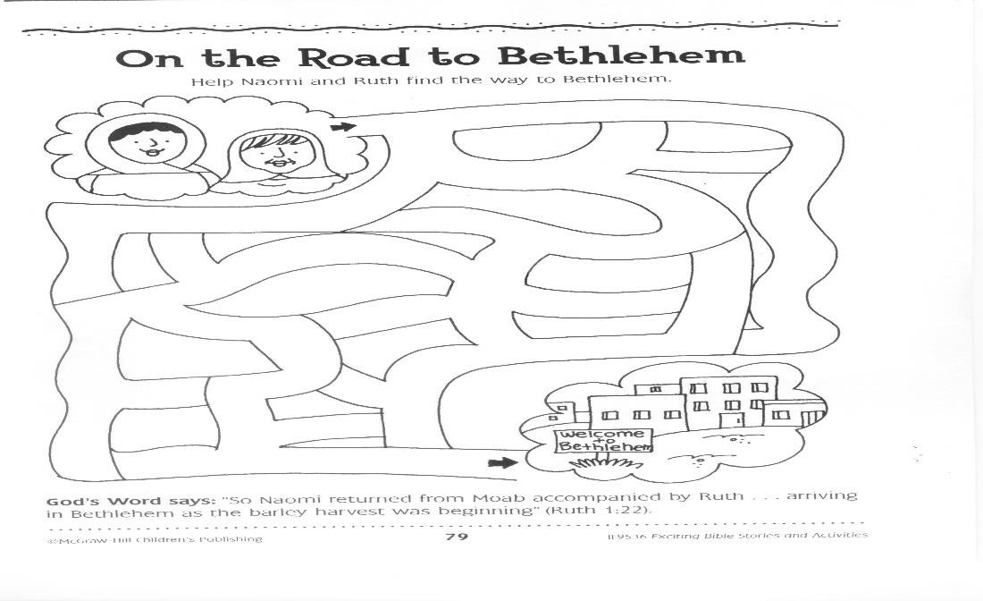

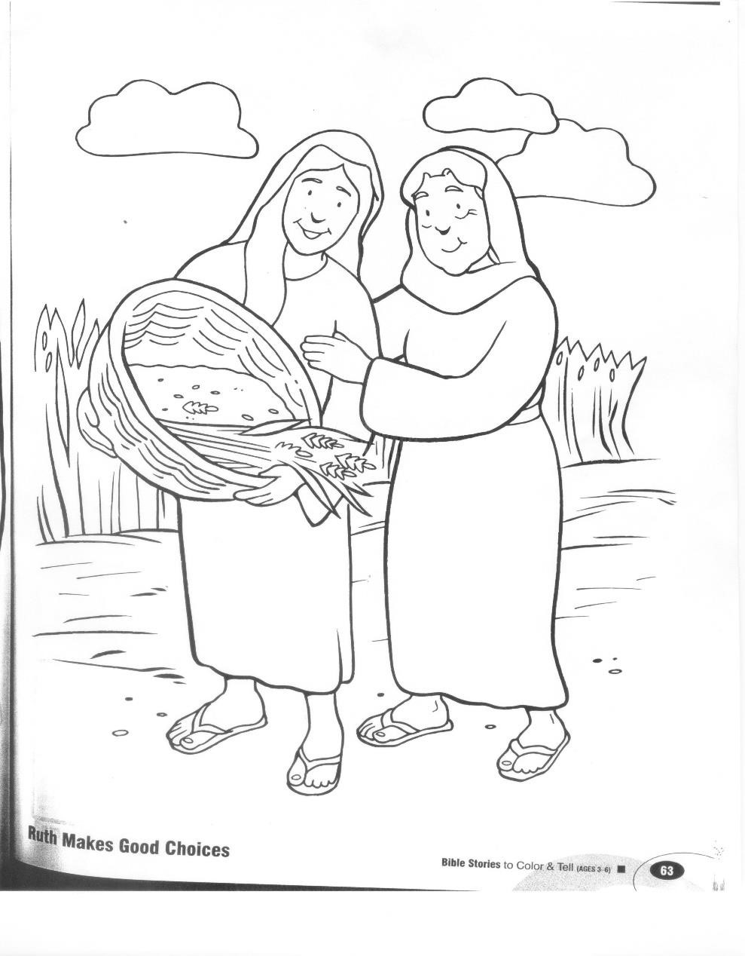

**? Answer to do you know.**

**● When he obeyed God.**